(Approx. 1910 words)

Syncing Android
By Dick Maybach, Member, Brookdale Computer Users’ Group, NJ
December 2017 issue, BUG Bytes
www.bcug.com
n2nd (at) att.net

Your Android-powered smart phone is a very capable device, but it becomes even more useful and convenient when linked to your PC. We carry our phones everywhere, making them subject to loss and damage, and it’s important that their data be backed up on a different device. Similarly, it can be important that your PC and phone have the same data; for example, if you change a PIN and record it only on your PC, your next trip to an ATM may be frustrating.

I have three types of data and a different way of syncing each.
- Contacts, calendar events, and Internet favorites are automatically synced over the Internet.
- Passwords, photos, and other files are transferred over my home network.
- Large files, such as music and book libraries are transferred directly to the phone’s SD card by mounting it on my PC.
These choices were driven by the version of Android I have, by the apps I’ve installed, by the operating system on my PC, and by security and cost considerations. You may prefer to use a program, such as Phone Companion for Windows 10 or Android File Transfer for OS X.

If you access e-mail via Webmail, that is by using a browser to link to your vendor’s Website, you no doubt keep your address list and perhaps your calendar there. If so, your contacts and your calendar are available no matter what device you use. However, if you use an email client on your PC and phone, you probably store your contact list and calendar on those devices, and it becomes a chore to maintain these data. One solution is to sync through your Gmail account, and because Google developed and supports Android, this is easy. All you must do is set up a Gmail account and register it with your phone; the two will automatically synchronize.

Now you must include your PC. Here is the process for Thunderbird, the email client associated with Firefox. (If you use another program, check its documentation.)
- Back up your contacts, for example by using the Thunderbird add-on Addressbooks Synchronizer.
- Install the Thunderbird add-on gContactSync.
- Select the Gmail account to be used.
- Google will create a second address book containing the contacts on your previously-synchronized devices.
- Select the address books to be synchronized by going to gContactSync then Edit Accounts. For the address book that Google added, set Groups and Contact to Synchronize to “All groups and contacts.” Disable sync for your other address books.
- Move your contacts from the existing Personal Address Book to the new one.
You’re finished; Google will sync your contact list every two hours.

The process to sync calendars is similar. Here it is for the Thunderbird e-mail client. (Again, if you use another program, check its documentation.)
- If you haven’t already, install the Thunderbird add-on Lightning, which adds the calendar function.
- Install the Thunderbird add-on “Provider for Google Calendar,” which provides calendar syncing.
- Select “Events and Tasks” then right-click in the left side panel and select “New Calendar.”
- Select “On the Network” then “Next.”
- Select “Google Calendar” then “Next.”
- Enter your Gmail address and sign in.
- Select the calendars and task lists to sync then “Next.”
- Select “Finish.”
Note: only events on the Google calendars are synchronized; you will probably want to copy those on your home calendar to Google's. Again, your Android device will handle things on its end, provided of course that you’ve linked it to the Gmail account.

While I’m willing to share my contacts, calendar, and favorites using the Internet, this isn’t so for my passwords, and I prefer to exchange large files (such as books, music, and photos) locally. To do this, you will need to know where Android stores it files and how to access them; see my November 2017 article, available at http://www.bcug.com. For transferring files between my PC and phone, I use our home wi-fi network and the File Transfer Protocol (FTP). The key here is a good Android file manager, such as ES File Explorer, for which you would use this procedure.
- Select the menu (at the upper left).
- Select Network.
- Select Remote Manager; the result is the screen in Figure 1.
- Select Turn On; you’ve now set up your Android device as a FTP server.
- In your PC’s FTP client enter the URL shown in Figure 1 as ftp://192.168.1.253:3721/, which translates to a host address of 192.168.1.253 and port 3721. (Your network might require different numbers.)
- You can now use FTP to exchange files between Android and your PC.
- Use the same procedure to transfer photos (from /DCIM/Camera on my Android) to your PC.

This works for all file transfers of course, and it avoids having to find the right USB cable. Important – be sure to turn off this function when you complete your transfers, as this FTP server uses no password. (This is the screen on a Motorola G⁴ using Android 7; screens on other configurations may differ.)

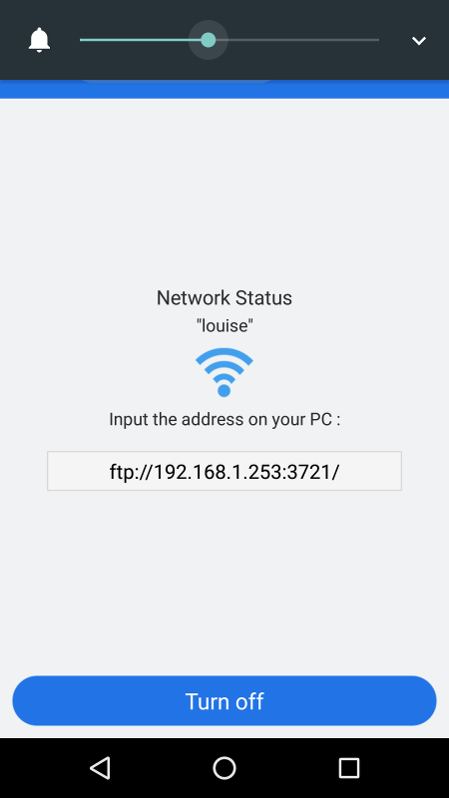
Figure 1. ES File Explorer FTP Screen.

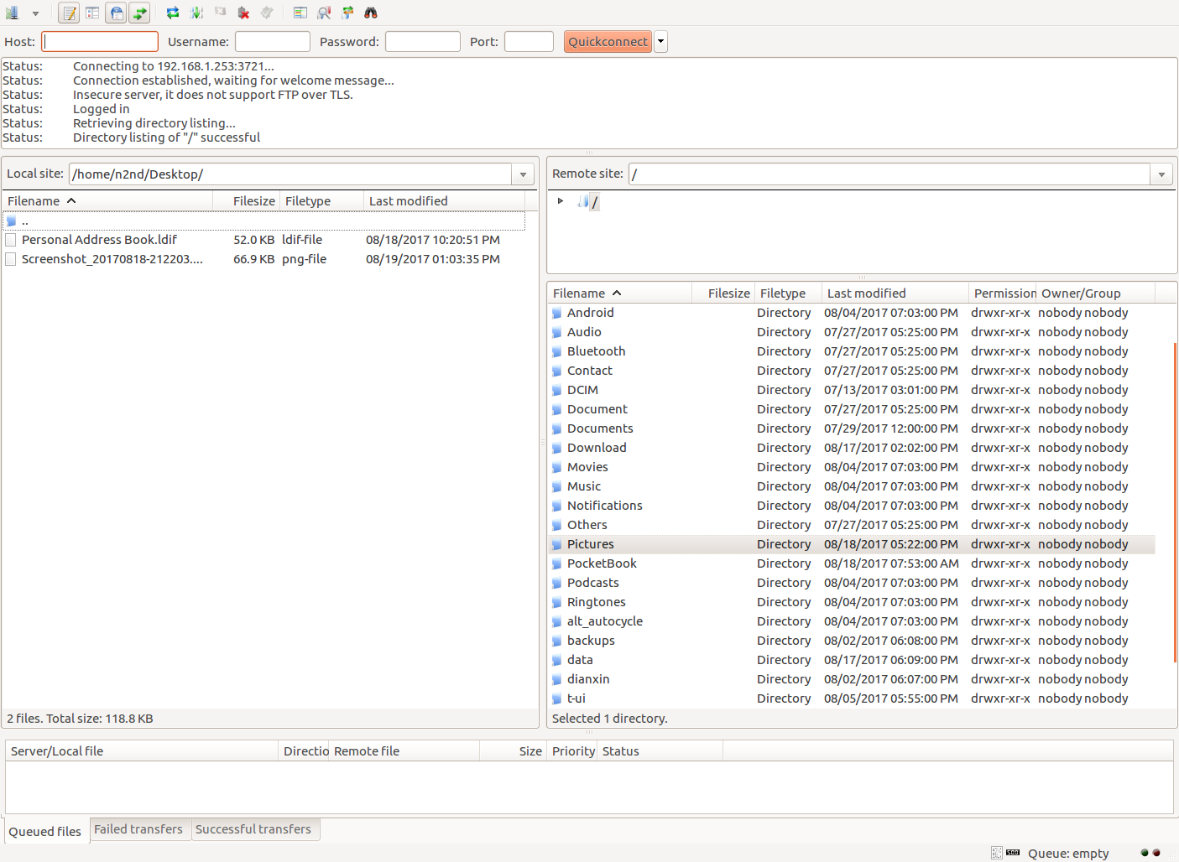
Figure 2. FileZilla Window View of an Android Device.

Figure 2 shows the PC FTP client FilaZilla (https://filezilla-project.org/, available for Linux, OS X, and Windows) looking at an Android device. The right pane is the home directory of the phone and the left one is a directory on the PC. Double-clicking on a directory name moves that window into it and double-clicking on the icon labeled “..” moves one directory higher. A right click on a filename gives you the options of uploading or downloading it, depending on whether you are in the left or right pane, and performing other file options (for example delete and rename). Alternatively, you could just drag files from one pane to another. The upper pane shows the session history, and the lower one (in this case) shows any queued transfers, although you could select a different tab to see other information.

There are alternative file transfer methods; for example, Bluetooth requires no cable and no local network. I find it less convenient than FTP, because its incoming files always appear in the same Android directory (/Bluetooth on my phone) and thus usually must be moved. The procedure for enabling Bluetooth depends not only on the operating system but also its version. Check the Internet for the setting up yours. You can also use a USB cable with the Media Transfer Protocol (MTP), although so far, I haven’t been successful with this.

A convenient way of managing files on the SD card is to remove it from the phone and mount it on a PC, especially if there is a lot of data. (Before opening your phone’s case, touch your PC case while holding your phone to discharge any static electricity.) I do this to transfer my music and e-book files. Both my media player (VLC) and e-book reader (Pocketbook Reader) easily find these on the SD card, the music in the directory /Music and the e-books in /Books. Instead of moving the SD card, you could use FTP to copy files to the local Android device and its file manager to move them to the SD card.

I’ve already discussed syncing your contacts, calendar, and e-mail through Google, which Android is designed to do. Safari can do this on Macs, and Chrome, Firefox and Thunderbird on Windows and Linux, and probably other clients as well; make an Internet search for the procedures for your case. Chrome can sync favorites using Google, and Firefox does the same with its own service. (Safari can sync contacts with an iOS device, but I don’t know about Android.) However, before synchronizing favorites, be sure you haven’t saved any critical passwords, such as for your bank. To be sure, remove all the sensitive URLs from your favorites. In the future, when you access a sensitive site, enter a password, and when your browser asks if it should remember it, the correct response is “Never for this site.”

You of course should back up your Android data either on the Internet or your PC. Even better, your PC should be able to access and use it. Many file formats are shared easily, for example, JPEG for photos, PNG for graphics, EPUB and PDF for documents, and MP3 for music. I’ve found a note editor (MonoSpace) whose text files can be shared with my PC. On my PC I use KeePassXC (KeePass and KeePassX are compatible) to manage my passwords, PINs, and similar sensitive data, which it stores in an encrypted database. The Android client Keepass2Android Password Safe uses the same database, making it easy to manage passwords and the like. (The KeePass database file is located at /Android/data/keepass2android.keepass2android/files/. It’s default name is keepass. kdbx, but you can change this providing you keep the same extension.)

As you’ve probably gathered, you must choose your PC and Android software carefully if you want to use the same data on both devices, and even then, you will find limitations. Copyrighted material is a case in point, as much of it is encumbered by Digital Rights Management (DRM). This “feature” often means that your music, videos, and e-books may be usable only on a few devices or in a few countries. (My wife recently downloaded a movie from Amazon, which she couldn’t watch in Europe. Her device’s GPS knew she was a part of the world where that movie wasn’t licensed.) Material with DRM limits may also require software that isn’t available for Android. You’re most likely to have DRM problems with material downloaded from such sources as iTunes, the Google PlayStore, and Amazon.

I use the VLC media player with DRM-free media on both systems, but even so there can be subtle problems. My audio files are organized with a separate directory for each album, and when I select a directory, VLC plays all the pieces in it. Since I prefer to listen to complete albums, I don’t need favorites lists. I can copy the library to my Android device and play my music the same way there. However, a favorite list of media files is a list of file locations, and since your Android file system is organized differently than your PC’s, you’ll need to compose separate lists for each. A favorite list of Internet radio stations, on the other hand, is a list of URLs, and it’s usable on both.

Data sharing is sometimes not possible. On Android I use Volkron’s CheckBook app to track my credit and debit card use. It records the same information you would write on a check stub, and I use it to reconcile my statements and so that I always know my account balances. Although there is no compatible PC application, CheckBook can e-mail comma-separated-variable (CSV) files (a separate one for each account), which in turn can be imported into a spreadsheet. Unfortunately, reverse transfers aren’t supported.

Because of this work, any changes you make to your calendar, your contacts, or your Internet favorites are automatically distributed to all the devices you’ve set up for syncing. Although it’s not automatic, you can easily share your passwords, photos, music, and books, perhaps with limitations. If you lose or damage your phone, all your information is still available on your other devices. Finally, backing up your PC now also backs up the important information on your phone, although you should continue to back the phone up separately.

